# Lab: Asynchronous Programming

This document defines the **in-class exercises** assignments for the ["C# Web Development Basics" course @ Software University](https://softuni.bg/courses/csharp-web-development-basics).

1. **Even Numbers Thread**

Print all even numbers in a given range. Printing should be executed on a separate thread. After finishing print "Thread finished work".

### Examples

|  |  |
| --- | --- |
| **Input** | **Output** |
| 1 10 | 2  4  6  8  10  Thread finished work |

### Hints

Use the Thread class and its methods Start() and Join().

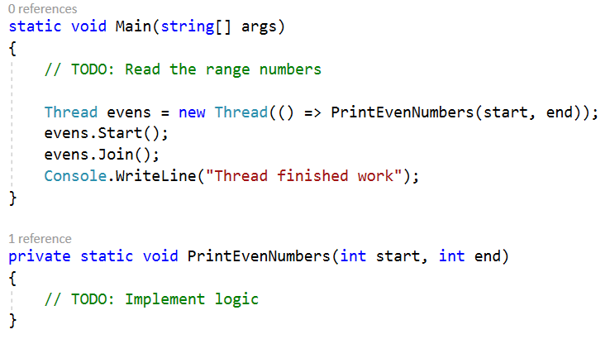

1. **Slice File**

Slice given file into given number of pieces. You will receive the name of the file, the destination folder to keep the pieces and the number of pieces.

While executing the operation the console interface should stay responsive.

### Examples

|  |  |
| --- | --- |
| C:\Users\RalitsaDelcheva\AppData\Local\Microsoft\Windows\INetCache\Content.Word\ZoomIt64_2017-09-03_16-04-23.png | C:\Users\RalitsaDelcheva\AppData\Local\Microsoft\Windows\INetCache\Content.Word\ZoomIt64_2017-09-03_16-05-31.png |

### Hints

Implement the slicing logic

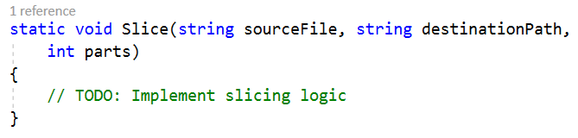

Inside this method check if the destination folder exists and if not – create it.

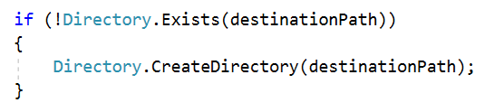

Open FileStream to read the source file and create FileInfo object to keep the source file data.

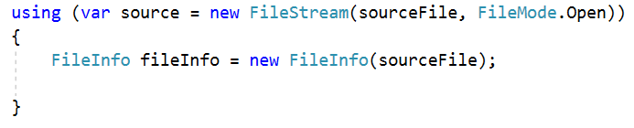

Start processing each new piece by creating its name.

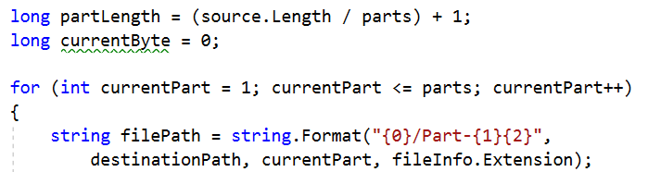

Open new stream to write the piece in the destination folder.

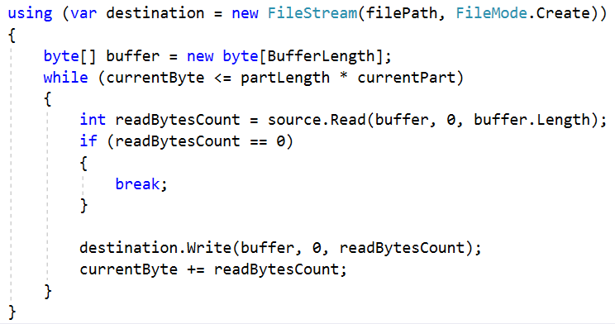

Print a message when the slicing is over.

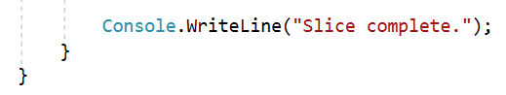

Write a method that runs a task with the slicing logic.

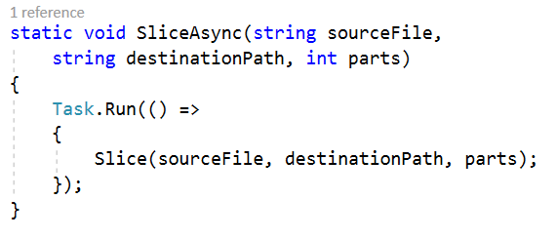

Read the input and call the method, that runs the task.

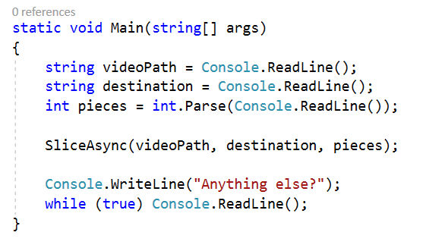

## Simple Web Server

Write a simple web server that receives requests from a client. Print the request to the console and send a message to the client.

### Examples

|  |  |
| --- | --- |
| **Input** | **Output** |
| C:\Users\RalitsaDelcheva\AppData\Local\Microsoft\Windows\INetCache\Content.Word\ZoomIt64_2017-09-05_20-05-53.png | C:\Users\RalitsaDelcheva\AppData\Local\Microsoft\Windows\INetCache\Content.Word\ZoomIt64_2017-09-05_19-58-26.png |
|  |

Note: Sent data may not be accepted by every browser (cough \*chrome\* cough).

### Hints

Write a task to connect with the client

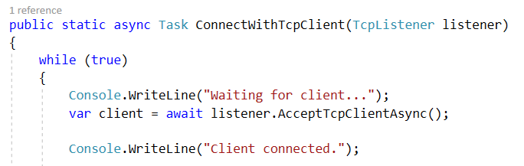

Read the request and print it on the console.

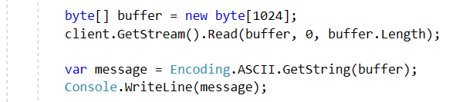

Send a greeting to the client.



Close the connection.

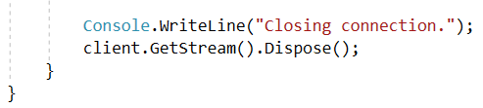

Create a TcpListener object a start the connection task.

